|  |  |  |  |  |  |  |  |  |
| --- | --- | --- | --- | --- | --- | --- | --- | --- |
| **#** | cantidad | descripion | medidas | precio unitario | total |  |  |  |
| **1** | 1 | mesa pecho de paloma | 180 L*60 ancho | $4500 | $4500 |  |  |  |
| **2** | 1 | escalera | 1,50 alto*50ancho | $1700 | $1700 |  |  |  |
| **3** | 1 | torre toscana | 1,80 largo*150 alto | $3000 | $3000 |  |  |  |
| **4** | 1 | cajonera |  | $600 | $600 |  |  |  |
| **5** | 1 | cubo |  | $200 | $200 |  |  |  |
| **3** | 1 | pottery barn | 1 mt largo*30 ancho | $600 | $600 |  |  |  |
|  |  |  |  |  |  |  |  |  |
|  | total |  |  |  | $10,600 |  |  |  |
|  |  |  |  |  |  |  |  |  |
|  |  |  |  |  |  |  |  |  |
|  | NOTA: las medidas del cubo y cajonera seràn determinadas una vez terminada la mesa para igualarlas a las de su imagen. | | | | | | | |
|  |  |  |  |  |  |  |  |  |
|  |  |  |  |  |  |  |  |  |
|  |  |  |  |  |  | Fecha de entrega 18 de Mayo | | |
|  |  |  |  |  |  |  |  |  |

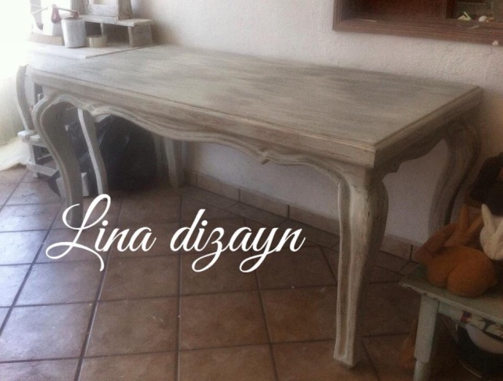 **# 1 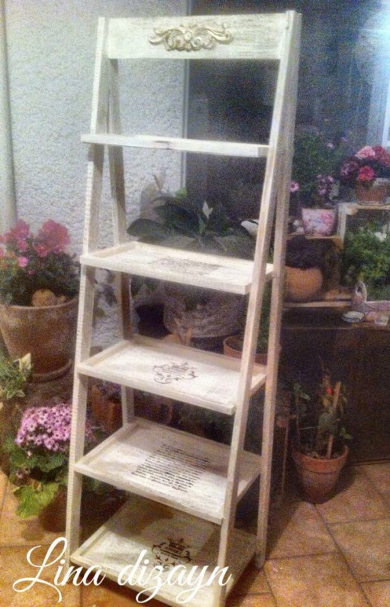 # 2**

**MESA ESCALERA**

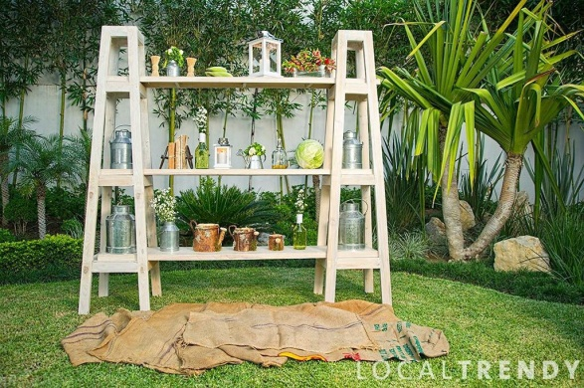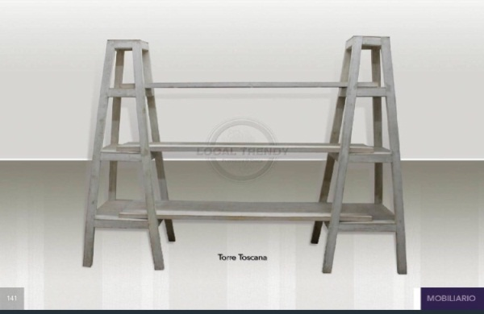 **# 3**

**TORRE TOSCANA**

**# 4 CAJONERA**

**# 5 CUBO**

**# 6** 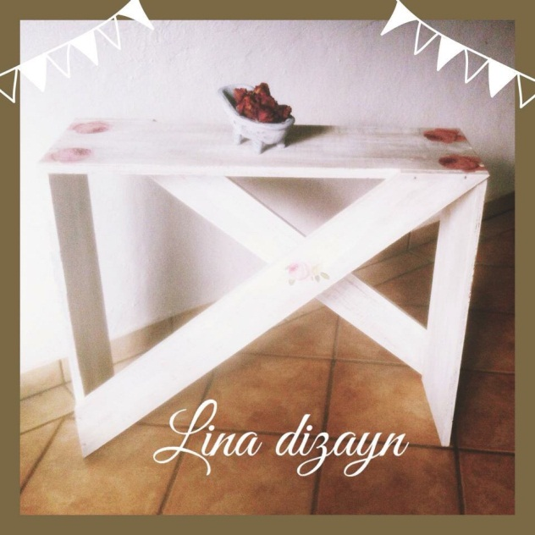

**MESA**